***SIGNS WITH SMART CONNECTIVITY FOR BETTER ROAD SAFETY***

# *SUBMITTED BY (*PNT2022TMID00922)

***ADHITHYAN.M.S***

***D.DHARUN ANTONY***

***BHARATHWAJ.NP***

***DINESH RAM.S***

***in partial fulfillment for the award of the degree of***

**BACHELOR OF ENGINEERING**

***in***

## ELECTRONICS AND COMMUNICATION ENGINEERING PANIMALAR ENGINEERING COLLEGE – CHENNAI

## NOV 2022

**ANNA UNIVERSITY: CHENNAI**

# BONAFIDE CERTIFICATE

Certified that this project report **“SIGNS WITH SMART CONNECTIVITY FOR BETTER ROAD SAFETY”** is the bonafide work of “**ADHITHYAN.M.S(211419106010), DHARUN ANTONY(211419106066), BHARATH WAJ(211419106046), DINESH RAM (211419106069)** who carried out the project work under my supervision.

**SIGNATURE OF HOD SIGNATURE OF MENTOR**

Dr.KANNAN Dr.S. Leones Sherwin Vimalraj

ElectronicsandCommunication Electronics andCommunication

Engineering Engineering

Panimalar Engineering college,

CONTENTS

1. **INTRODUCTION** 1.1Project Overview 1.2Purpose
2. **LITERATURESURVEY**
   1. Existing problem
   2. References
   3. Problem Statement Definition
3. **IDEATION & PROPOSEDSOLUTION**
   1. Empathy Map Canvas
   2. Ideation &Brainstorming
   3. Proposed Solution
   4. Problem Solution fit
4. **REQUIREMENTANALYSIS**
   1. Functional requirement
   2. Non-Functional requirements
5. **PROJECTDESIGN**
   1. Data Flow Diagrams
   2. Solution & TechnicalArchitecture
   3. User Stories
6. **PROJECT PLANNING &SCHEDULING**
   1. Sprint Planning & Estimation
   2. Sprint Delivery Schedule
   3. Reports from JIRA
7. **CODING & SOLUTIONING (Explain the features added in the project along withcode)**
   1. Feature 1
   2. Feature 2
   3. Database Schema (ifApplicable)
8. **TESTING**
   1. Test Cases
   2. User AcceptanceTesting
9. **RESULTS**
   1. Performance Metrics
10. **ADVANTAGES &DISADVANTAGES**
11. **CONCLUSION**
12. **FUTURE SCOPE**
13. **APPENDIX**

Source Code

GitHub & Project Demo Link

# 1. Introduction:

Roads are the foremost source of linking between cities and villages. Due to the ease of traveling by road, vehicles have become the main way people travel. The chances of vehicular accidents (Vas) have increased with the growing number of vehicles on the roads. During a journey, one does not know what will happen on the next road, particularly during bad weather conditions (BWC). In such a situation, driving can be difficult due to bad visibility, which can lead to an accident. It was also noticed that in BWC, multiple vehicle collisions (MVCs) can occur owing to delays in receiving information about an incident. According to one study by the Islamabad police, there were 9582 accidents from 2016 to 2017 all over Pakistan, involving 11,317 vehicles, leading to 5047 fatalities and 12,696 persons injured

Digital technologies like the Internet of Things (IoT) are reshaping road safety measures. Many technology initiatives are undertaken the world over to make smarter and safer roads, the ones that can interact with traffic and pedestrians. Assuming that by giving in vehicle technology information to the driver, accidents can be averted, several technology-based products have been developed. The latest technology researchers are working on is based on the Internet of Things (IoT). IoT is all about data. Data is becoming a valuable resource for our world.

Many sectors and industries have adopted IoT to reduce errors and improve performance in manufacturing, energy, health care, and communication. The WHO describes different measures that can be implemented with minimal economic impacts in its “Save LIVES: Road Safety Technical Package”. A cornerstone of these steps is realizing economic systems for “monitoring road safety by strengthening data systems”. Meanwhile, a key theme in the package is motivating the adoption of a Safe System approach, which is a holistic approach to road safety that parts from traditional management solutions by emphasizing safety by design.

Mobile-phone-based applications use built-in sensor data to detect the speed limit based on environmental situations.

The main contributions of this research are

1. Abriefsurveyonthestateoftheartrelatedtopre-accidentaswellaspost-accident models, frameworks, andtechniques;
2. Identificationandreportingoflimitationsinpreviousstudiesrelatedtoaccident detection;
3. The concept of a smart road with an event-sensing capability, plus implementation and testing through variousexperiments;
4. Demonstrationofanewandmodernwaytoquicklydetectaccidentsand communicate with nearby vehicles andEOCs.

The risks for loss of life, injuries, and other damage may increase if an incident is not reported to an EOC in a timely fashion. Lives can be saved by sending timely information about an accident through an automated mechanism. Moreover, quick automobile accident detection and an alert system are required to protect approaching vehicles against an MVC. Several methods have been implemented in advanced vehicles (Avs) for avoiding an accident. An accident threat is detected through sensors installed in vehicles or by using smartphone sensors. Previous researchers have used accelerometers, smoke detectors, infrared (IR) obstacle sensors, proximity sensors, and biosensors to detect an accident.

## 1.1. Project Overview:

The main aim of this project is to help people automate the roads by providing them with a Web App through which they can monitor the parameters of the road like temperature, speed limit, and visibility of the road.They also show guides for schools and provide services of displaying hospitals, and restaurant signs accordingly.

## 1.2Purpose:

A large amount of research is being carried out in the domain of accident avoidance and accident alarms by a large number of researchers and practitioners. To avoid accidents, many approaches are utilized to enhance safety. For ease of reference, the literature on accident detection and avoidance is separated into three approaches: stand-alone, cooperative, and hybrid. Stand-alone approaches use sensors, such as radar and light detection and ranging (LiDAR), for accident avoidance and detection, whereas cooperative approaches rely on V2X technology and hybrid approaches.

## LITERATURE SURVEY:

**Abstract:**

In present Systems the road signs and the speed limits are Static. But the road signs can be changed in some cases.We can consider some cases when there are

road diversions due to heavy traffic or due to accidents then we can change the road signs accordingly if they are digitalized. This project proposes a system that has digital signboards on which the signs can be changed dynamically. If there is rainfall then the roads will be slippery and the speed limit would be decreased. There is a web app through which you can enter the data on road diversions, accident-prone areas, and information sign boards can be entered through the web app. This data is retrieved and displayed on the signboards accordingly

**Introduction:**

An automated deep learning (DL)-based system was developed for detecting accidents from video data. The system uses visual components in temporal order to represent traffic collisions. As a result, the model architecture is composed of a visual-features-extraction phase followed by transient pattern identification. Convolution and recurrent layers are used in the training phase to learn visual and temporal features. In public traffic accident datasets, an accuracy of 98% was attained in the detection of accidents, demonstrating a strong capacity for detection independent of the road structure. The solution is limited to automobile crashes, not motorbikes, bicycles, and pedestrians. Furthermore, the model makes mistakes when determining accident segments under poor illumination (e.g., at night), at low resolutions, and when there are occlusions.

An accident management system was proposed in that makes use of cellular technology in public transportation. This method enables communication across various components, including those in ambulances, RSUs, and servers. Furthermore, in this system, an optimal route-planning algorithm (ORPA) is proposed to optimize aggregate spatial utilization of road networks while lowering the travel cost to operate a vehicle. The ORPA was evaluated through simulations, and findings were compared with other current algorithms. In congested areas, the proposed method can also be used to offer fast routes for ambulances. All vehicles, including ambulances, are required to have a route indicator installed, as well as the ability to use remote correspondence. The ORPA outperformed in terms of average speed and travel duration, according to the evaluation data. The proposed system only works for predicted patterns and can fail due to the unpredicted behavior of traff

## Existingproblem:

**The Safe System Approach**

The Safe System (SS) approach to transport networks originated with the “Safe Road Transport System” model developed by the Swedish Transport Agency. In its essence, the approach migrates from the view that accidents are largely and

automatically the driver’s fault to a view that identifies and evaluates the true causes of accidents. Through the categorization of safety into the safety of three elements (vehicle, road, and road user), SS minimizes fatalities and injuries by controlling speeds and facilitating prompt emergency response. The model has been widely adopted since its introduction and is currently motivated by the WHO as a basis for road safety planning, policy-making, and enforcement

## REFERENCE:

* + 1. World Health Organization, “Global status report on road safety 2015,”<https://www.who.int/violence_injury_prevention/road_safety_status/2015/en/>. View at: [GoogleScholar](https://scholar.google.com/scholar_lookup?title=Global%20status%20report%20on%20road%20safety%202015&author=World%20Health%20Organization)
    2. World Health Organization, “Decade ofAction for Road Safety 2011-2020 seeks to save millions of lives,”<http://www.who.int/roadsafety/decade_of_action/en/>.

View at: [Publisher Site](https://doi.org/10.18356/36e51ced-en) | [Google Scholar](https://scholar.google.com/scholar_lookup?title=Decade%20of%20Action%20for%20Road%20Safety%202011-2020%20seeks%20to%20save%20millions%20of%20lives&author=World%20Health%20Organization)

* + 1. F. Wegman, “The future of road safety: A worldwide perspective,” *IATSS Research*, vol. 40, no. 2, pp. 66–71,2017.

View at: [Publisher Site](https://doi.org/10.1016/j.iatssr.2016.05.003) | [Google Scholar](https://scholar.google.com/scholar_lookup?title=The%20future%20of%20road%20safety%3A%20A%20worldwide%20perspective&author=F.%20Wegman&publication_year=2017)

* + 1. World HealthOrganization,“SaveLIVES-Aroadsafetytechnical package,”2017.

View at: [Google Scholar](https://scholar.google.com/scholar_lookup?title=Save%20LIVES%20-%20A%20road%20safety%20technical%20package&author=World%20Health%20Organization)

* + 1. W. E. Marshall, “Understanding international road safety disparities: Why is Australia so much safer than the United States?” *Accident Analysis & Prevention*, vol. 111, pp. 251–265,2018.

View at: [Publisher Site](https://doi.org/10.1016/j.aap.2017.11.031) | [Google Scholar](https://scholar.google.com/scholar_lookup?title=Understanding%20international%20road%20safety%20disparities%3A%20Why%20is%20Australia%20so%20much%20safer%20than%20the%20United%20States%3F&author=W.%20E.%20Marshall&publication_year=2018)

* + 1. “Open Street Maps, with New York Countyhighlighted,”<https://www.openstreetmap.org/relation/2552485>.

View at: [Google Scholar](https://scholar.google.com/scholar_lookup?title=Open%20Street%20Maps%2C%20with%20New%20York%20County%20highlighte)

* + 1. United States Census Bureau, “TIGER/Line® Shapefiles: Roads,”[https://www.census.gov/cgi-bin/geo/shapefiles/index.php?year=2018&amp](https://www.census.gov/cgi-bin/geo/shapefiles/index.php?year=2018&amp%3Blayergroup=Roads)

[;layergroup=Roads](https://www.census.gov/cgi-bin/geo/shapefiles/index.php?year=2018&amp%3Blayergroup=Roads). View at: [Google Scholar](https://scholar.google.com/scholar_lookup?title=TIGER%2FLine%26%23xae%3B%20Shapefiles%3ARoads&author=United%20States%20Census%20Bureau)

* + 1. X. Wang, X. Wu, M. Abdel-Aty, and P. J. Tremont, “Investigation of road network features and safety performance,” *Accident Analysis & Prevention*, vol. 56, pp. 22–31,2013.

View at: [Publisher Site](https://doi.org/10.1016/j.aap.2013.02.026) | [Google Scholar](https://scholar.google.com/scholar_lookup?title=Investigation%20of%20road%20network%20features%20and%20safety%20performance&author=X.%20Wang&author=X.%20Wu&author=M.%20Abdel-Aty&author=P.%20J.%20Tremont&publication_year=2013)

* + 1. EuropeanRoadAssessmentProgram(EuroRAP),“EuropeanRoadSafety Atlas,”<http://atlas.eurorap.org/>.

View at: [Google Scholar](https://scholar.google.com/scholar_lookup?title=European%20Road%20Safety%20Atlas&author=European%20Road%20Assessment%20Program%20(EuroRAP))

* + 1. EuropeanRoadAssessmentProgramme(EuroRAP),“StarRatings,”<http://www.eurorap.org/protocols/star-ratings/>.

View at: [Google Scholar](https://scholar.google.com/scholar_lookup?title=Star%20Ratings&author=European%20Road%20Assessment%20Programme%20(EuroRAP))

* + 1. International Road Assessment Programme (iRAP),“iRAP,”<https://www.irap.org/>.

View at: [Google Scholar](https://scholar.google.com/scholar_lookup?title=iRAP&author=International%20Road%20Assessment%20Programme%20(iRAP))

* + 1. H.M.HassanandH.Al-Faleh,“Exploringtheriskfactorsassociatedwith the size and severity of roadway crash in Riyadh,” *Journal of Safety Research*, vol. 47, pp. 67–74,2013.

View at: [Publisher Site](https://doi.org/10.1016/j.jsr.2013.09.002) | [Google Scholar](https://scholar.google.com/scholar_lookup?title=Exploring%20the%20risk%20factors%20associated%20with%20the%20size%20and%20severity%20of%20roadway%20crashes%20in%20Riyadh&author=H.%20M.%20Hassan&author=H.%20Al-Faleh&publication_year=2013)

* + 1. E. Ahmed, I. Yaqoob, A. Gani, M. Imran, and M. Guizani, “Internet-of-things-based smart environments: State of theart, taxonomy, and open research challenges,” *IEEE Wireless Communications Magazine*, vol. 23, no. 5, pp. 10–16, 2016. View at: [Publisher Site](https://doi.org/10.1109/MWC.2016.7721736) | [GoogleScholar](https://scholar.google.com/scholar_lookup?title=Internet-of-things-based%20smart%20environments%3A%20State%20of%20the%20art%2C%20taxonomy%2C%20and%20open%20research%20challenges&author=E.%20Ahmed&author=I.%20Yaqoob&author=A.%20Gani&author=M.%20Imran&author=M.%20Guizani&publication_year=2016)
    2. Y. Mehmood, F. Ahmad, I. Yaqoob, A. Adnane, M. Imran, and S. Guizani, “Internet-of-Things-BasedSmartCities:RecentAdvancesandChallenges,” *IEEE Communications Magazine*, vol. 55, no. 9, pp. 16–24,2017. View at: [Publisher Site](https://doi.org/10.1109/MCOM.2017.1600514) | [Google Scholar](https://scholar.google.com/scholar_lookup?title=Internet-of-Things-Based%20Smart%20Cities%3A%20Recent%20Advances%20and%20Challenges&author=Y.%20Mehmood&author=F.%20Ahmad&author=I.%20Yaqoob&author=A.%20Adnane&author=M.%20Imran&author=S.%20Guizani&publication_year=2017)
    3. AARON,“GPSLoggerincludingGyro/Tilt/Compass&Accelerometer,”<https://www.aaronia.com/products/spectrum-analyzers/gps-logger/>.

View at: [Google Scholar](https://scholar.google.com/scholar_lookup?title=GPS%20Logger%20including%20Gyro%20%2F%20Tilt%20%2F%20Compass%20%26%23x26%3B%20Accelerometer&author=AARONIA)

* + 1. M. Farsi, K. Ratcliff, and M. Barbosa, “Overview of controller area network,” *Computing and Control Engineering Journal*, vol. 10, no. 3, pp. 113–120, 1999. View at: Publisher Site | [GoogleScholar](https://scholar.google.com/scholar_lookup?title=Overview%20of%20controller%20area%20network&author=M.%20Farsi&author=K.%20Ratcliff&author=M.%20Barbosa&publication_year=1999)
    2. MUNIC (company website),<https://www.munic.io/>.
    3. Torque Pro (OBD 2 & Car), “Torque Pro (OBD2 & Car) Google Play Page,”<http://goo.gl/CWD5VT>.

View at: [Google Scholar](https://scholar.google.com/scholar_lookup?title=Torque%20Pro%20(OBD2%20%26%23x26%3B%20Car)%20Google%20Play%20Page&author=Torque%20Pro%20(OBD%202%20%26amp%3B%20Car))

19.J.-S. Zhou, S.-H.Chen, W.-D.Tsay, and M.-C. Lai, “The implementation of OBD-II vehicle diagnosis system integrated with cloud computation technology,” in *Proceedings of the 2013 2nd International Conference on Robot, Vision and Signal Processing, RVSP 2013*, pp. 9–12, Japan, December 2013.

View at: [Google Scholar](https://scholar.google.com/scholar_lookup?title=The%20implementation%20of%20OBD-II%20vehicle%20diagnosis%20system%20integrated%20with%20cloud%20computation%20technology&author=J.-S.%20Jhou&author=S.-H.%20Chen&author=W.-D.%20Tsay&author=M.-C.%20Lai)

1. A. Mednis, A. Elsts, and L. Selavo, “Embedded solution for road condition monitoringusingvehicularsensornetworks,”in*Proceedingsofthe20126th InternationalConferenceonApplicationofInformationandCommunication Technologies, AICT 2012*, Georgia, October2012.

View at: [Google Scholar](https://scholar.google.com/scholar_lookup?title=Embedded%20solution%20for%20road%20condition%20monitoring%20using%20vehicular%20sensor%20networks&author=A.%20Mednis&author=A.%20Elsts&author=L.%20Selavo)

1. M.Yamada, K. Ueda, I. Horiba, and N. Sugie, “Discrimination of the Road Condition Toward Understanding of Vehicle Driving Environments,” *IEEE Transactions on Intelligent Transportation Systems*, vol. 2, no. 1, pp. 26–31,2001.

View at: [Publisher Site](https://doi.org/10.1109/6979.911083) | [Google Scholar](https://scholar.google.com/scholar_lookup?title=Discrimination%20of%20the%20Road%20Condition%20Toward%20Understanding%20of%20Vehicle%20Driving%20Environments&author=M.%20Yamada&author=K.%20Ueda&author=I.%20Horiba&author=N.%20Sugie&publication_year=2001)

1. J.Eriksson,L.Girod,B.Hull,R.Newton,S.Madden,andH.Balakrishnan, “The pothole patrol: using a mobile sensor network for roadsurfacemonitoring,” in *Proceedings of the 6th International Conference on Mobile Systems, Applications, and Services (MobiSys '08)*, pp. 29–39, Breckenridge, Colo, USA, June 2008.

View at: [Publisher Site](https://doi.org/10.1145/1378600.1378605) | [Google Scholar](https://scholar.google.com/scholar_lookup?title=The%20pothole%20patrol%3A%20using%20a%20mobile%20sensor%20network%20for%20road%20surface%20monitoring&author=J.%20Eriksson&author=L.%20Girod&author=B.%20Hull&author=R.%20Newton&author=S.%20Madden&author=H.%20Balakrishnan)

1. M. Valentino, C. Quiligotti, and L. Carone, “Branchial cleft cyst,” *Journal of Ultrasound*, vol. 16, no. 1, pp. 17–20,2013.

View at: [Publisher Site](https://doi.org/10.1007/s40477-013-0004-2) | [Google Scholar](https://scholar.google.com/scholar_lookup?title=Branchial%20cleft%20cyst&author=M.%20Valentino&author=C.%20Quiligotti&author=L.%20Carone&publication_year=2013)

## Problem StatementDefinition

A problem statement is a concise description of an issue to be addressed or a condition to be improved upon. It identifies the gap between the current (problem) state and desired (goal) state of a process or product. Focusing on the facts, the problem statement should be designed to address the [Five Ws](https://en.wikipedia.org/wiki/Five_Ws). The first condition of solving a problem is understanding the problem, which can be done by way of a problem statement.

In present Systems the road signs and the speed limits are Static. But the road signs can be changed in some cases. We can consider some cases when there are road diversions due to heavy traffic or due to accidents then we can change the road signs accordingly if they are digitalized. This project proposes a system that has digital signboards on which the signs can be changed dynamically. If there is rainfall then the roads will be slippery and the speed limit would be decreased. There is a web app through which you can enter the data on road diversions, accident-prone areas, and information sign boards can be entered through the web app. This data is retrieved and displayed on the signboardsaccordingly.

## IDEATION & PROPOSED SOLUTION:

* 1. **Empathy MapCanvas:**

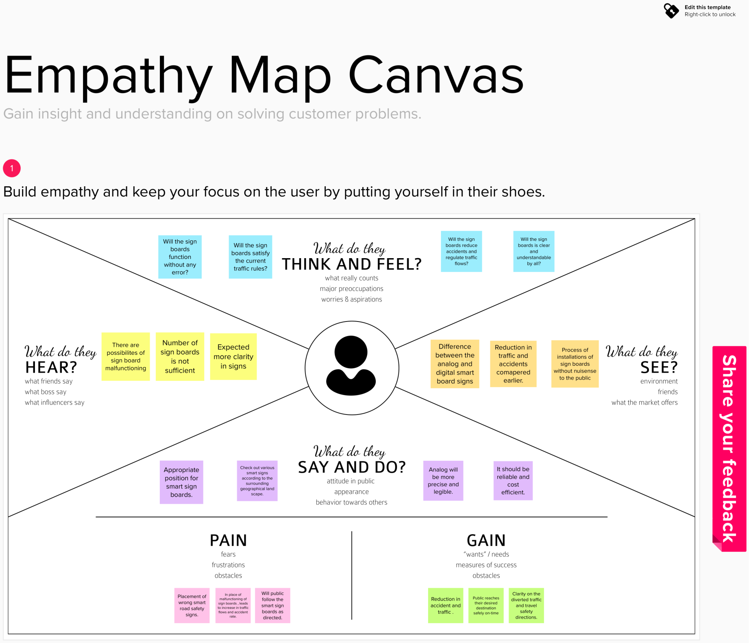

* 1. **Ideation &Brainstorming:**

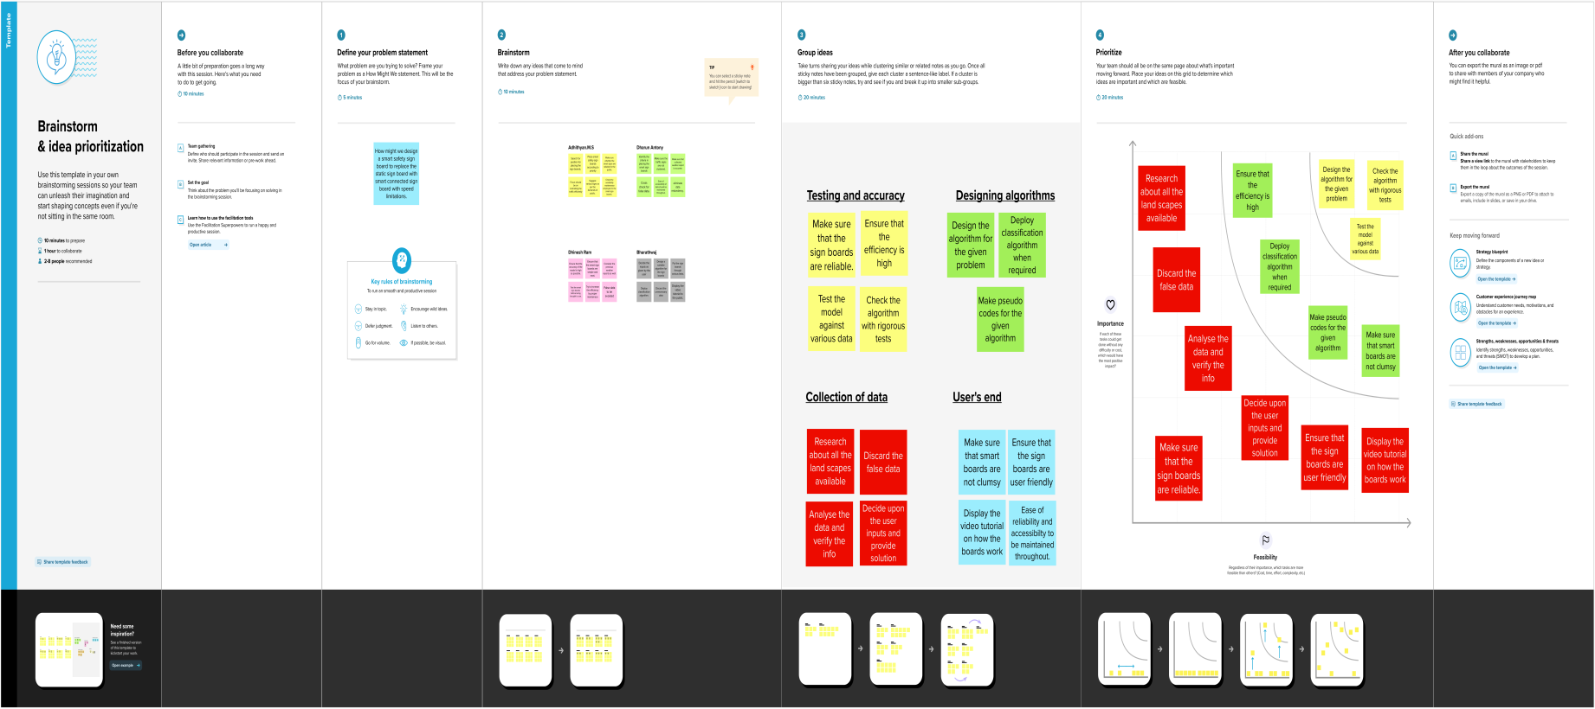

* 1. **Proposed Solution:**

The project team shall fill in the following information in the proposed solution template.

|  |  |  |
| --- | --- | --- |
| **S.No.** | **Parameter** | **Description** |
| 1. | ProblemStatement(Problemtobesolved) | To replace the static signboards, smart connected sign boards are used which get the speed limitations from a web app using weather API and update automatically. |
| 2. | Idea/Solutiondescription | Predicting the speed limit from data acquired through weather map and pass through a web user interface which in turn used by user |
| 3. | Novelty/Uniqueness | Controllingthe speed limit by weather map. |
| 4. | SocialImpact/CustomerSatisfaction | Based on traffic diversion signs ,guide signs and warning signs are displayed to the public. |
| 5. | BusinessModel(RevenueModel) | Smart connectivity and better road safety model. |
| 6. | ScalabilityoftheSolution | Theprocessof understanding and operatingthisModeliseasy and its highly scalable with proper efficiency. |

## Problem Solutionfit:

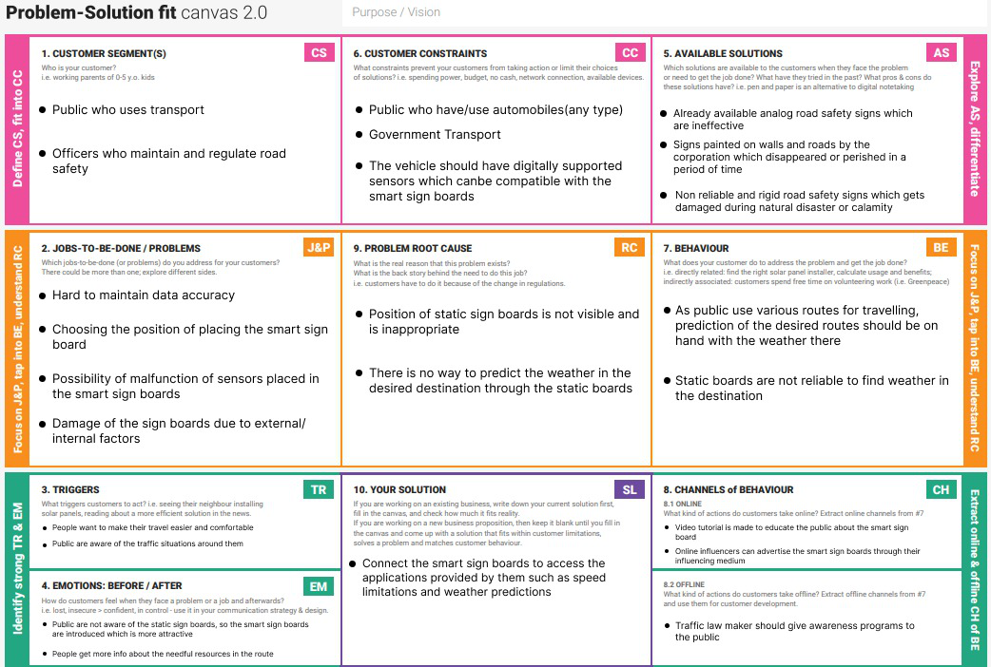

1. **REQUIREMENTANALYSIS**
   1. **Functionalrequirement:**

|  |  |  |
| --- | --- | --- |
| **FR No.** | **Functional Requirement (Epic)** | **Sub Requirement (Story / Sub-Task)** |
| FR-1 | **User Visibility** | Sign Boards should be made with LED’s which are bright colored and are capable of attracting the drivers attention but it should also not be too distracting or blinding cause it may lead to accidents. |
| FR-2 | **User Need** | The smart sign boards should be placed frequently in places it is needed and less in places where it is not needed much to avoid confusion for the user during travel. |
| FR-3 | **User Understanding** | For better understanding of the driver, the signs should be big, clear and legible and it can also include illustrations which will make it easily understandable to the driver. |
| FR-4 | **User Convenience** | The display should be big enough that it should even be visible from far distance clearly. |

* 1. **Non-Functionalrequirements:**

|  |  |  |
| --- | --- | --- |
| **FR No.** | **Non-Functional Requirement** | **Description** |
| NFR-1 | **Usability** | It should be able to Upgrade and Update when there is a need for it. |
| NFR-2 | **Security** | It should have good security system so that no other person is able to hack and display their own directions. |
| NFR-3 | **Reliability** | It should be able to display to information correctly and  error-free. |
| NFR-4 | **Performance** | It should be able to automatically update itself when certain weather or traffic problem occurs. |
| NFR-5 | **Availability** | It should be available 24/7 so that it can be beneficial to  the customer i.e the driver. |
| NFR-6 | **Scalability** | It should be able to easily change and upgrade according to change and need in requirement. |

1. **PROJECTDESIGN:**

Project design is an early phase of the project lifecycle where ideas, processes, resources, and deliverables are planned out. A project design comes before a project plan as it's a broad overview whereas a project plan includes more detailed information.

## Data FlowDiagrams:

A Data Flow Diagram (DFD) is a traditional visual representation of the information flows within a system. A neat and clear DFD can depict the right amount of the system requirement graphically. It shows how data enters and leaves the system, what changes the information, and where data is stored.

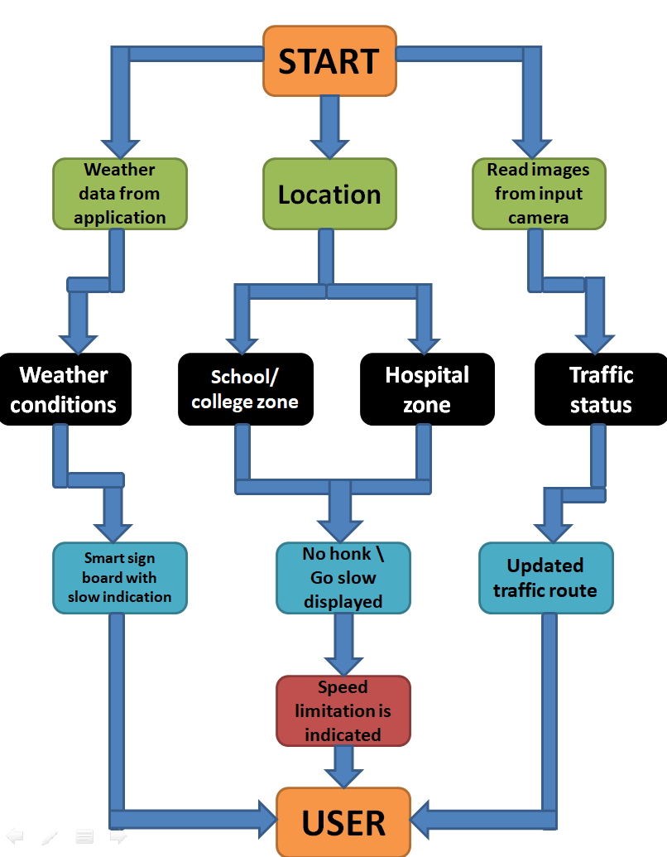

## Solution &TechnicalArchitecture:

## 

* 1. **Userstories:**

Use the below template to list all the user stories for the product.

|  |  |  |  |  |  |  |
| --- | --- | --- | --- | --- | --- | --- |
| User Type | Functional  Requirement (Epic) | User Story Number | **UserStory/Task** | **Acceptancecriteria** | Priority | Release |
| Customer (Mobile user) | Registration | USN-1 | **I can get my speed limitation using weather application .** | **I can receive speed limitations** | High | Sprint-1 |
|  |  | USN-2 | **As a user, I can register for the application by entering my email, password, and confirming my password. As a user,** | **I can access my account / dashboard** | Medium | Sprint-2 |
|  |  | USN-3 | **As a user, I can increase or decrease my speed according to the weather change** | **I can increase or decrease my speed** | High | Sprint-1 |
|  |  | USN-4 | **As a user, I can I get my traffic diversion signs depending on the traffic and the fatal situations.** | **I can access my traffic status ahead in my travel** | Medium | Sprint-1 |
|  | Login | USN-5 | **As a user, I can log into the open weather map by entering email & password** | **I can access the application through my Gmail login** | High | Sprint-2 |
|  | Interface | USN-6 | **As a user the interface should be simple and easily accessible** | **I can access the interface easily** | High | Sprint-1 |
| Customer (Web user) | Data generation | USN-7 | **As a user I use open weather application to access the data regarding the weather changes.** | **I can access the data regarding the weather through the application** | High | Sprint-1 |
| Administrator  (Officials) | Problem solving/ Fault clearance | USN-8 | **As an official who is in charge for the proper functioning of the sign boards have to maintain it through periodic monitoring.** | **Officials can monitor the sign boards for proper functioning.** | Medium | Sprint-2 |
|  |  |  | **entering my email, password, and confirming my password** | **dashboard** |  |  |

## PROJECT PLANNING &SCHEDULING

The definition of a sprint is a dedicated period in which a set amount of work will be completed on a project. It’s part of the agile methodology, and an Agile projectwill be broken down into a number of sprints, each sprint taking the project closer to completion**.**

## Sprint Planning &Estimation:

Use the below template to create product backlog and sprint schedule

|  |  |  |  |  |  |  |
| --- | --- | --- | --- | --- | --- | --- |
| **Sprint** | **Functional**  **Requirement(Epic)** | **User Story**  **Number** | **UserStory/Task** | **Story Points** | **Priority** | **Team**  **Members** |
| Sprint-1 | Registration | USN-1 | As a user, I can register for the application byentering my email, password, and confirmingmypassword. | 2 | High | ADHITHYAN |
| Sprint-1 |  | USN-2 | As a user, I will receive confirmation email onceIhave registeredforthe application | 1 | High | ADHITHYAN |
| Sprint-1 |  | USN-3 | As a user, I can register for the applicationthroughFacebook | 2 | Low | ADHITHYAN |
| Sprint-1 |  | USN-4 | Asa user,Icanregisterforthe application  throughGmail | 2 | Medium | DHARUN ANTONY |
| Sprint-1 | Login | USN-5 | As a user, I can log into the application byenteringemail & password | 1 | High | DHARUN ANTONY |
| Sprint-1 | Dashboard | USN-6 | As a user, I can log into the application byenteringemail& passwordandaccessallthe  resourcesandservicesavailable | 2 | High | DHARUN ANTONY |

## Sprint Delivery Schedule:

**Project Tracker, Velocity & Burndown Chart:**

|  |  |  |
| --- | --- | --- |
| TITLE | DESCRIPTION | DATE |
| Literature Survey&InformationGathering | A literature review is acomprehensive summaryofpreviousresearchesonthe topic. The literaturereview surveys scholarlyarticles, books, and othersourcesrelevantto a  particular area ofresearch. | 3September2022 |
| PrepareEmpathyMap | Anempathymapisacollaborative tool teamscan use to gain a deeperinsight into theircustomers. It helps us tounderstandthecustomers’pain,gainanddifficulties  fromtheir pointofview. | 10September2022 |
| Ideation-Brainstorming | Brainstorming is agroupproblem-solving  method that helped us togather and organizevarious ideas andthoughts fromteam  members. | 17September2022 |
| DefineProblemstatement | TheCustomerProblemStatementhelpsustofocus on what matters tocreate experiences peoplewill love. A well-articulatedcustomer problemstatementallowedustofindthe idealsolutionforthechallengescustomersface. | 19September2022 |
|  |  |  |
| Problem Solution Fit | It helped us understandand analyze all thethoughtsofourcustomer,their choice of options,problems,rootcause,  behaviorandemotions. | 26September2022 |
| Proposed solution | It helped us analyze andexamine our solution morein the grounds ofuniqueness, social impact,businessmodel,scalability  etc. | 28 September2022 |
| Solution Architecture | Solution architecture is acomplex process – withmany sub-processes –that bridges the gapbetween businessproblems and technologysolutions. It helped usunderstand the featuresandcomponentsusedto  completetheproject. | 1 October2022 |
| Customer journey map | It helped to analyse thevarious steps, interactions,goals and motivation,positives,negativesand  opportunities. | 7 October2022 |
| Solution requirements | It briefs about functionaland non-functionalrequirements. It involvesthe various steps in theentire process. It alsospecifies featuresusability,security,  reliability, performance,availabilityandscalability. | 12October2022 |
| Technology stack | A tech stack is the combination of technologies a company uses to build and run an application or project. It helps us analyse and understand various technologies that needs to be implemented in the  project. | 15October2022 |
| Dataflow | A Data Flow Diagram(DFD)isatraditional  visualrepresentationof | 11October2022 |
|  | theinformationflowswithin a system. A neatand clear DFD can depictthe right amount of thesystem requirementgraphically. It shows howdataentersandleavesthesystem, what changes theinformation, and wheredataisstored. |  |
| SprintDeliveryplan | Sprint Planning is an eventin scrum that defines whatcan be delivered in theupcomingsprint andhowthat work will be achieved.It helps us to organise andcomplete the workeffectivelyandefficiently. | 22 October2022 |
| Preparemilestoneandactivitylist | Helps us understand andevaluate our progress andaccuracy so far. | 23October2022 |
| ProjectDevelopment-DeliveryofSprint-1 | Develop and submit thedeveloped code by testingit. | 7 november 2022 |

**Velocity:**

Imagine we have a 10-day sprint duration, and the velocity of the team is 20 (points per sprint). Let’s calculate the team’s average velocity (AV) per iteration unit (story points per day)



**Burndown Chart:**

A burn-down chart is a graphical representation of work left to do versus time. It is often used in agile software development methodologies such as scrum. However, burn-down charts can be applied to any project containing measurable progress over time.

**8.CODING & SOLUTIONING:**

**(Explain the features added in the project along with code):**

* 1. **Feature 1 (coding andresult):**

importwiotp.sdk.device import time

import random

importibmiotf.application import ibmiotf.device import requests, json

myConfig = { #Configuration "identity": {

"orgId": "3dpjnk",

"typeId": "Sign_Board", "deviceId":"Board_1"},

#API Key

"auth": {

"token": "1234567890"

}

}

#Receiving callbacks from IBM IOT platform defmyCommandCallback(cmd):

print("Message received from IBM IoT Platform: %s" % cmd.data['command']) m=cmd.data['command']

client = wiotp.sdk.device.DeviceClient(config=myConfig,logHandlers=None) client.connect()

#OpenWeatherMap Credentials

BASE_URL ="https://api.openweathermap.org/data/2.5/weather?" CITY = "Nagercoil"

URL = BASE_URL + "q=" + CITY + "&units=metric"+"&appid=" + "01df65417ab3968e3fc2a38c4aee27bb"

while True:

response = requests.get(URL) if response.status_code ==200:

data = response.json() main = data['main'] temperature =main['temp']

humidity = main['humidity'] pressure = main['pressure'] report = data['visibility']

#messge part msg=random.randint(0,5) if msg==1:

message="SLOW DOWN, SCHOOL IS NEAR"

elifmsg==2:

message="NEED HELP, POLICE STATION AHED"

elifmsg==3:

message="EMERGENCY, HOSPITAL NEARBY"

elifmsg==4:

message="DINE IN, RESTAURENT AVAILABLE"

else:

message="" #Speed Limit part

speed=random.randint(0,150) if speed>=100:

speedMsg=" Limit Exceeded" elif speed>=60 and speed<100:

speedMsg="Moderate" else:

speedMsg="Slow"

#Diversion part sign=random.randint(0,5) if sign==1:

signMsg="Right Diversion" elifsign==3:

signMsg="Left Diversion" elifsign==5:

signmsg="U Turn" else:

signMsg=""

#Visibility

if temperature < 24:

visibility="Fog Ahead, Drive Slow" elif temperature < 20:

visibility="Bad Weather" else:

visibility="Clear Weather"

else:

print("Error in the HTTP request")

myData={'Temperature':temperature, 'Message':message, 'Sign':signMsg, 'Speed':speedMsg, 'Visibility':visibility}

client.publishEvent(eventId="status", msgFormat="json", data=myData, qos=0, onPublish=None) #PUBLISHING TO IOT WATSON

print("Published data Successfully: %s", myData) client.commandCallback = myCommandCallbacktime.sleep(5)

client.disconnect()

**Output:**

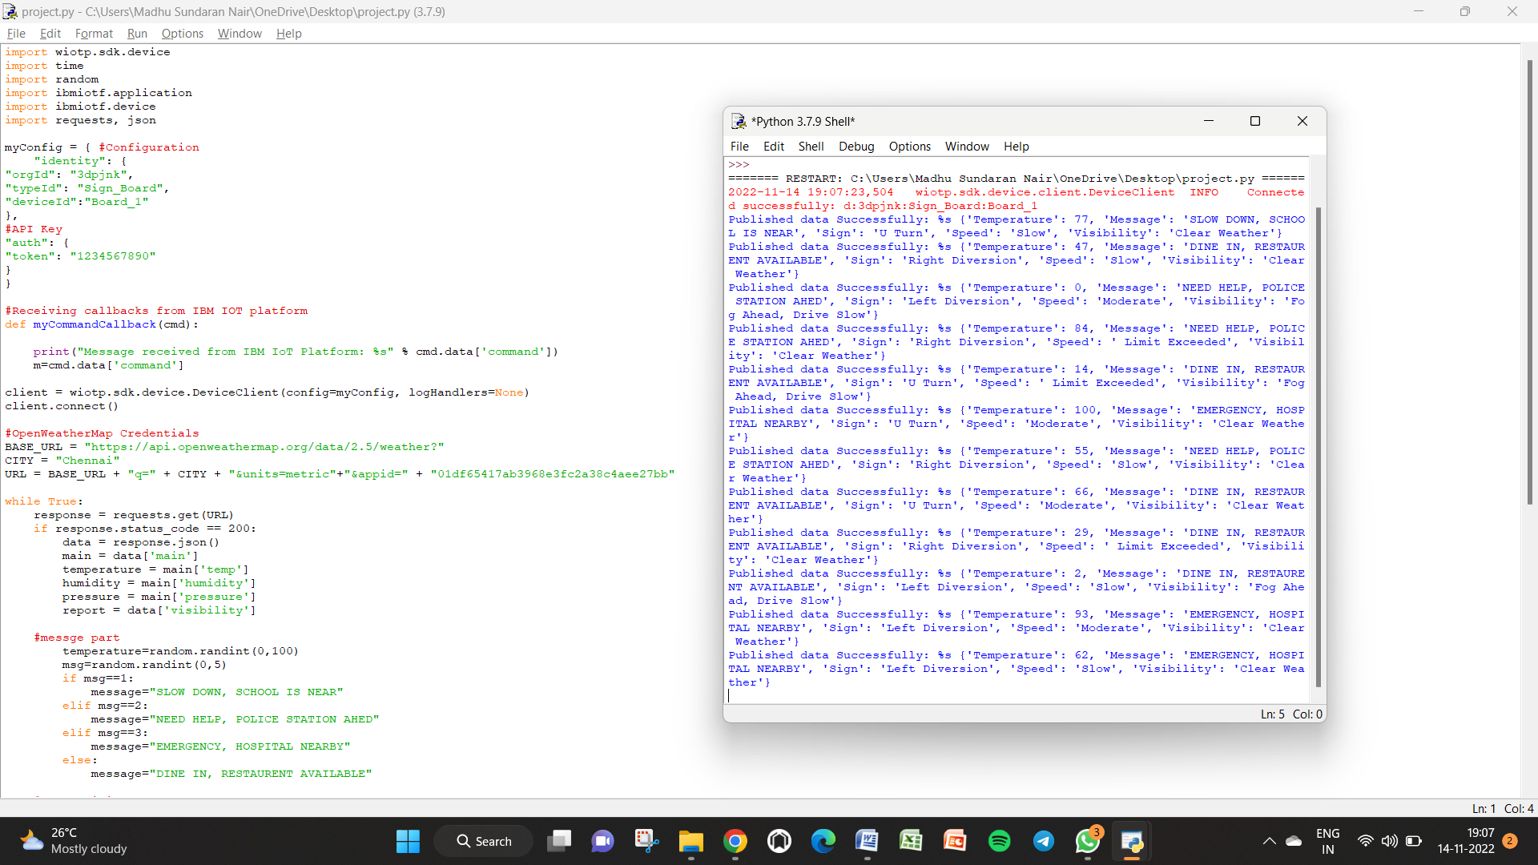

* 1. **Feature 2: (MITAPPINVENTER):**

MIT APP INVENTOR: ICON PAGE:

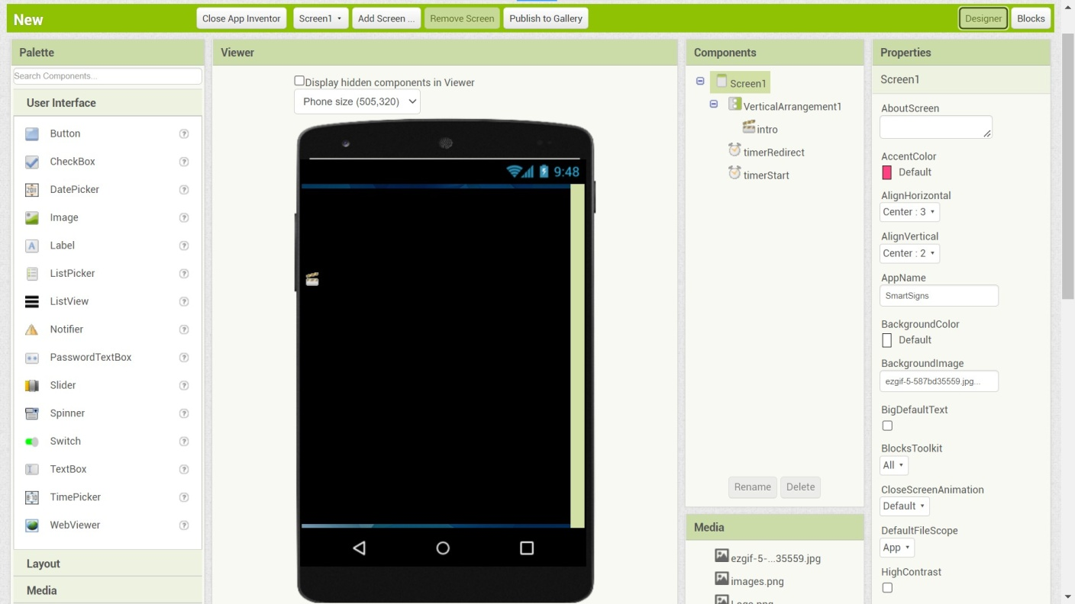

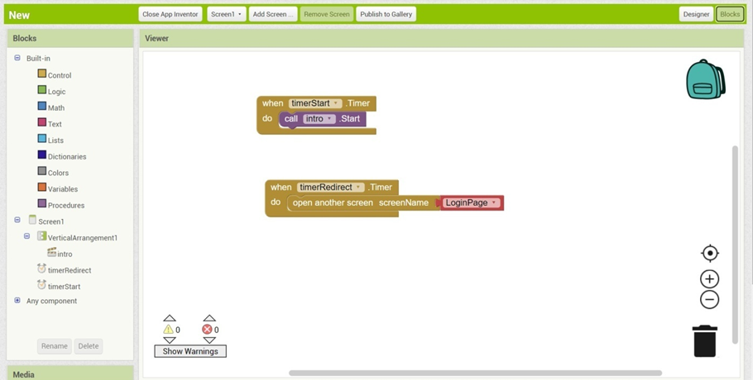

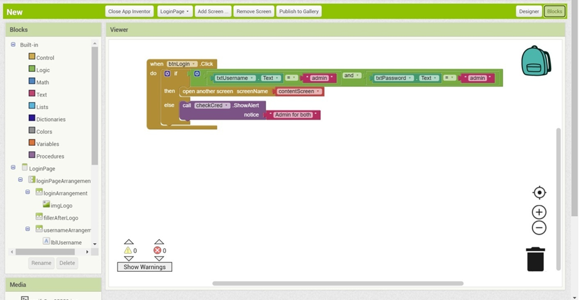

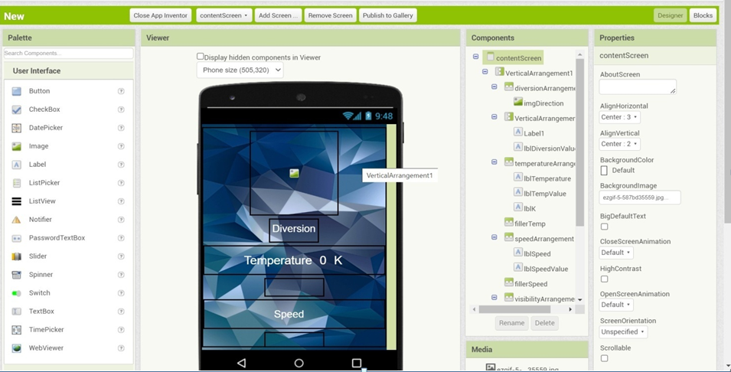

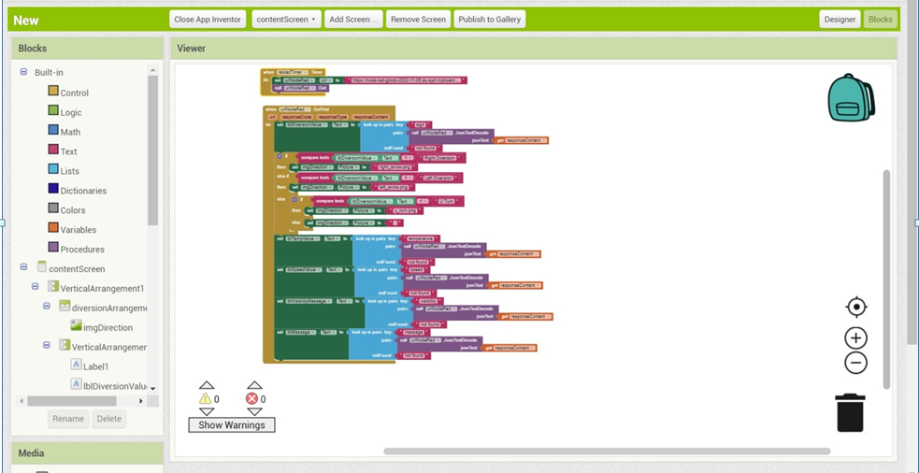

## TESTING:

Test cases help guide the tester through a sequence of steps to validate whether a software application is free of bugs, and working as required by the end-user.

Learning how to write test cases for software requires basic writing skills, attention to detail, and a good understanding of the application under test (AUT).

## TestCases:

UI : <https://node-red-rnlku-2022-11-04.eu-gb.mybluemix.net/ui/#!/0?socketid=45tMkCVwyfqy0tETAABh>

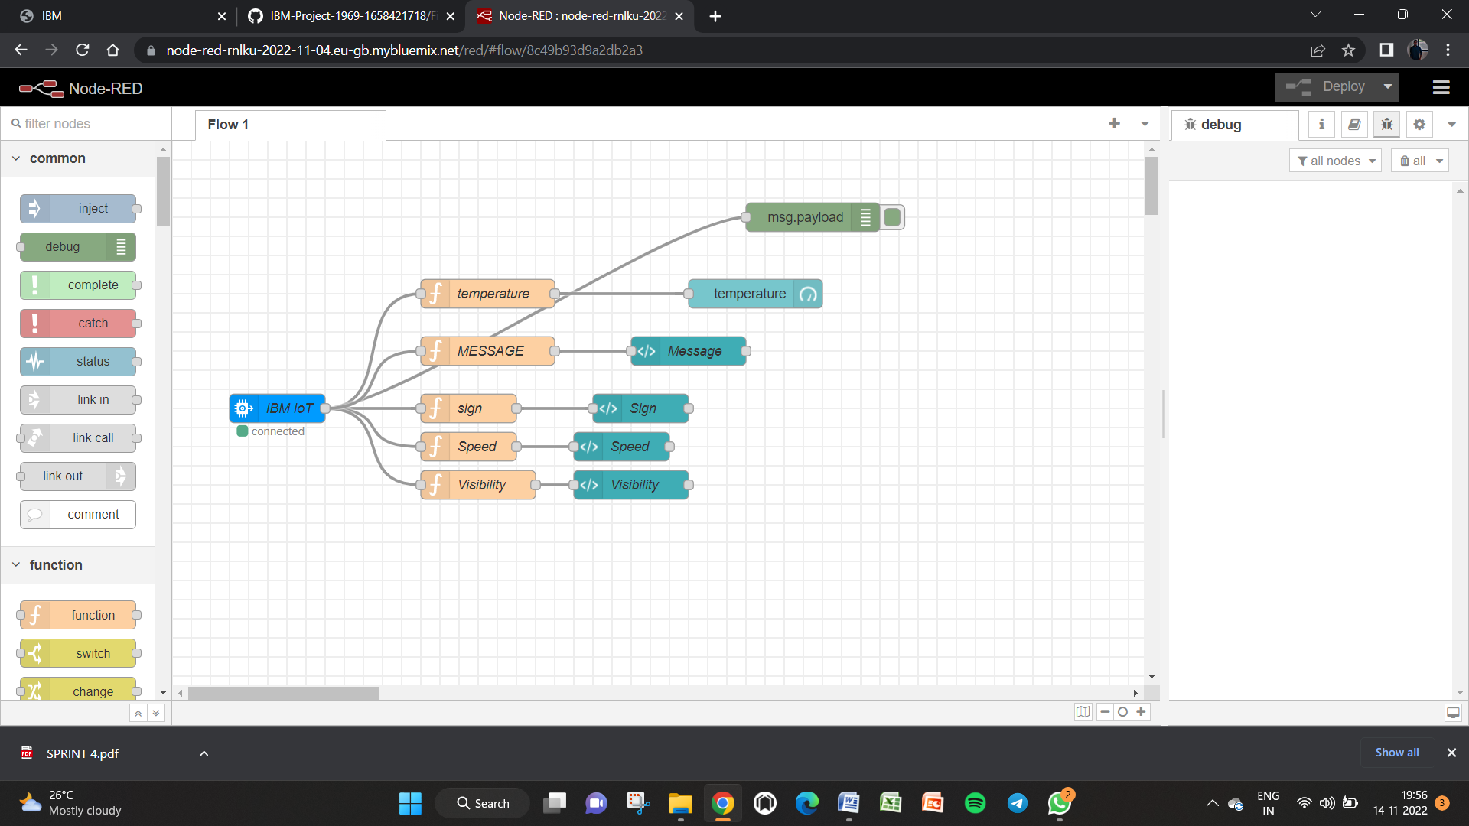

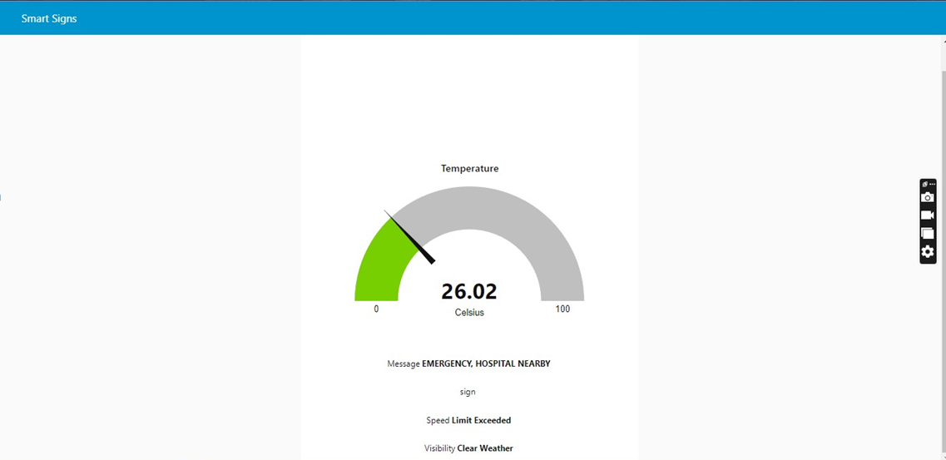

* 1. **User AcceptanceTesting:**

UAT consists, in practice, of people from the target audience using the application. The defects they find are then reported and fixed. This scenario is what most closely resembles “the real world.” The process allows users to

“get their hands dirty” with the application. They can see if things work as intended**.**

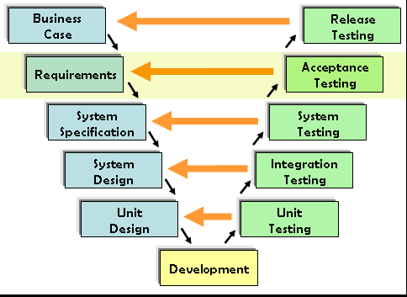

The main purpose of UAT is to validate end-to-end business flow. It does not focus on cosmetic errors, spelling mistakes, or system testing. User Acceptance Testing is carried out in a separate testing environment with a production-like data setup. It is a kind of black box testing where two or more

end-users will be involved.

## RESULTS:

* 1. **PerformanceMetrics:**

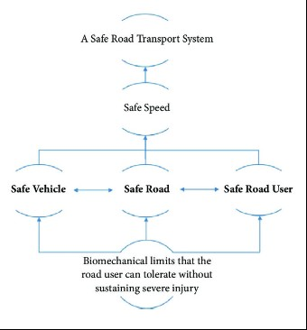

1. **ADVANTAGES & DISADVANTAGES**

**Advantages:**

Connected vehicles have various benefits such as

* Multimodalsensorsandedgecomputinghelpspeeduptheflowoftrafficwithreal-time processing, reducing congestion andemissions.
* Smart road technology can assist in optimizing trafficflow
* It will manage road conditions, creating a more sustainable environment withincities.
* Improved control and safety can be achieved through IoT-enabled cars. In case of over-speeding, the notification getsdisplayed.
* Ensuring a safe driving experience with real-time assistance, navigation, and even monitoring driving patterns and any emergency. Additionally, along with the state of the traffic, IoT drivers can receive updated information on the state of the roads, i.e., potholes, ice, grade changes, black spots,etc.

## DISADVANTAGES:

* Security and privacy. Keeping the data gathered and transmitted by IoT devices safe is challenging, as they evolve and expand in use....
* Technical complexity....
* Connectivity and power dependence....
* Integration....
* Higher costs (time andmoney)

## CONCLUSION:

The world doesn’t change on its own but we humans can change the world to be safe, better, and harmless. Since the road isn’t said to be safe let’s make it safer with the technologies present and available to us. The Internet of Things is one of the technologies that can lead us to travel on enhanced safe roads. So let's come together to create a better world with no accidents and a smart road for the future generation.

## FUTURESCOPE:

IoT obtains the majority of its data with the help of connected cars. These incorporate a large number of sensors that establish communication with the cloud, other vehicles, and devices. Thanks to this it provides data and information of great utility for the improvement of road safety. The safe system approach to road safety emphasizes safety by desigh ensuring safe vehicles, road networks, and road users. Evolving towards the future, the road needs to boil with advanced sensors and antenna systems to have peace with the new era.

## APPENDIX:

**Source Code:**

importwiotp.sdk.device import time

import random

importibmiotf.application import ibmiotf.device import requests, json

myConfig = { #Configuration "identity": {

"orgId": "3dpjnk",

"typeId": "Sign_Board", "deviceId":"Board_1"},

#API Key

"auth": {

"token": "1234567890"

}

}

#Receiving callbacks from IBM IOT platform defmyCommandCallback(cmd):print("Message received from IBM IoT Platform: %s" % cmd.data['command']) m=cmd.data['command']

client = wiotp.sdk.device.DeviceClient(config=myConfig,logHandlers=None) client.connect()

#OpenWeatherMap Credentials

BASE_URL ="https://api.openweathermap.org/data/2.5/weather?" CITY = "Chennai"

URL = BASE_URL + "q=" + CITY + "&units=metric"+"&appid=" + "01df65417ab3968e3fc2a38c4aee27bb"

while True:

response = requests.get(URL) if response.status_code ==200:

data = response.json() main = data['main'] temperature =main['temp']

humidity = main['humidity'] pressure = main['pressure'] report = data['visibility']

#messge part msg=random.randint(0,5) if msg==1:

message="SLOW DOWN, SCHOOL IS NEAR"

elifmsg==2:

message="NEED HELP, POLICE STATION AHED"

elifmsg==3:

message="EMERGENCY, HOSPITAL NEARBY"

elifmsg==4:

message="DINE IN, RESTAURENT AVAILABLE"

else:

message=""

#Speed Limit part speed=random.randint(0,150) if speed>=100:

speedMsg=" Limit Exceeded" elif speed>=60 and speed<100:

speedMsg="Moderate" else:

speedMsg="Slow"

#Diversion part sign=random.randint(0,5) if sign==1:

signMsg="Right Diversion" elifsign==3:

signMsg="Left Diversion" elifsign==5:

signmsg="U Turn" else:

signMsg=""

#Visibility

if temperature < 24:

visibility="Fog Ahead, Drive Slow" elif temperature < 20:

visibility="Bad Weather" else:

visibility="Clear Weather"

else:

print("Error in the HTTP request")

myData={'Temperature':temperature, 'Message':message, 'Sign':signMsg, 'Speed':speedMsg, 'Visibility':visibility}

client.publishEvent(eventId="status", msgFormat="json", data=myData, qos=0, onPublish=None) #PUBLISHING TO IOT WATSON

print("Published data Successfully: %s", myData) client.commandCallback = myCommandCallbacktime.sleep(5)

client.disconnect()

## GitHub Link :

<https://github.com/IBM-EPBL/IBM-Project-1969-1658421718>

Project demo link :

<https://youtu.be/iJvhOudqiV4>